# Django CRM Project 1

Date: 15-May-2021

Source : <https://www.youtube.com/watch?v=fOukA4Qh9QA>

Tools :

* IDE : VS Code
* Language : Python

VS Code extensions :

* Django Templates and Backend snippets : by Roberth Solis
* Django Template : by bibhasdn

What is Django ?

* A Python web development framework

## Project Setup:

* Create virtual environment by:

Navigate to the project folder via command line.

Install virtual environment libraries of python : *pip install virtualenv*

Create virtual environment in the project folder : virtualenv <env name>

* Activate the Virtual Environment

On Windows : <env name>\Scripts\activate

On Mac : source <env name>/bin/activate

My Proj: py_proj1_virenv/Scripts/activate

( my project env is “py_proj1_virenv” )

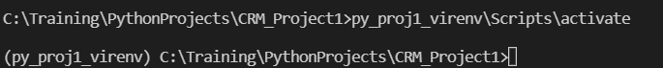

* Deactivate the Environment

*“deactivate” – command to deactivate the virtual env.*

* Install Django in the virtual environment

*pip install django==3.1.4*

* Check if all packages are installed properly

*pip freeze*

# Create the Django Project

* Create and start the Django project

*“django-admin startproject <project name><space><dot(.)>”*

django-admin startproject django_crm1 .

* Add .gitignore int the virtual env folder ( <https://github.com/github/gitignore/blob/master/Python.gitignore> )
* Add to source control
* Click on source control - give the path of the folder containing the virtual env folder and project folder.

# Set Git Account for the Project

Run

  git config --global user.email "you@example.com"

  git config --global user.name "Your Name"

to set your account's default identity.

Omit --global to set the identity only in this repository.

# Start the Server

* *“python manage.py runserver”*